What is Computer?
A computer is an electronic device that accepts data from the user, processes it, produces results, displays them to the users, and stores the results for future usage.

Data is a collection of unorganized facts & figures and does not provide any further information regarding patterns, context, etc. Hence data means “unstructured facts and figures”.

Information is a structured data i.e. organized meaningful and processed data. To process the data and convert into information, a computer is used.

Functions of Computers?
A computer performs the following functions −

Receiving Input
Data is fed into computer through various input devices like keyboard, mouse, digital pens, etc. Input can also be fed through devices like CD-ROM, pen drive, scanner, etc.

Processing the information
Operations on the input data are carried out based on the instructions provided in the programs.

Storing the information
After processing, the information gets stored in the primary or secondary storage area.

Producing output
The processed information and other details are communicated to the outside world through output devices like monitor, printer, etc.

Characteristics of Computer System

Speed
A computer works with much higher speed and accuracy compared to humans while performing mathematical calculations. Computers can process millions (1,000,000) of instructions per second. The time taken by computers for their operations is microseconds and nanoseconds.

Accuracy
Computers perform calculations with 100% accuracy. Errors may occur due to data inconsistency or inaccuracy.

Diligence
A computer can perform millions of tasks or calculations with the same consistency and accuracy. It doesn’t feel any fatigue or lack of concentration. Its memory also makes it superior to that of human beings.

Versatility
Versatility refers to the capability of a computer to perform different kinds of works with same accuracy and efficiency.

Reliability
A computer is reliable as it gives consistent result for similar set of data i.e., if we give same set of input any number of times, we will get the same result.
Automation
Computer performs all the tasks automatically i.e. it performs tasks without manual intervention.

Memory
A computer has built-in memory called primary memory where it stores data. Secondary storage are removable devices such as CDs, pen drives, etc., which are also used to store data.

Basic Applications of Computer

Home
Computers are used at homes for several purposes like online bill payment, watching movies or shows at home, home tutoring, social media access, playing games, internet access, etc. They provide communication through electronic mail. They help to avail work from home facility for corporate employees. Computers help the student community to avail online educational support.

Medical Field
Computers are used in hospitals to maintain a database of patients’ history, diagnosis, X-rays, live monitoring of patients, etc. Surgeons nowadays use robotic surgical devices to perform delicate operations, and conduct surgeries remotely. Virtual reality technologies are also used for training purposes. It also helps to monitor the fetus inside the mother’s womb.

Entertainment
Computers help to watch movies online, play games online; act as a virtual entertainer in playing games, listening to music, etc. MIDI instruments greatly help people in the entertainment industry in recording music with artificial instruments. Videos can be fed from computers to full screen televisions. Photo editors are available with fabulous features.

Industry
Computers are used to perform several tasks in industries like managing inventory, designing purpose, creating virtual sample products, interior designing, video conferencing, etc. Online marketing has seen a great revolution in its ability to sell various products to inaccessible corners like interior or rural areas. Stock markets have seen phenomenal participation from different levels of people through the use of computers.

Education
Computers are used in education sector through online classes, online examinations, referring e-books, online tutoring, etc. They help in increased use of audio-visual aids in the education field.

Government
In government sectors, computers are used in data processing, maintaining a database of citizens and supporting a paperless environment. The country’s defense organizations have greatly benefitted from computers in their use for missile development, satellites, rocket launches, etc.

Banking
In the banking sector, computers are used to store details of customers and conduct transactions, such as withdrawal and deposit of money through ATMs. Banks have reduced manual errors and expenses to a great extent through extensive use of computers.

Business
Nowadays, computers are totally integrated into business. The main objective of business is transaction processing, which involves transactions with suppliers, employees or customers. Computers can make these transactions easy and accurate. People can analyze investments, sales, expenses, markets and other aspects of business using computers.

Training
Many organizations use computer-based training to train their employees, to save money and improve performance. Video conferencing through computers allows saving of time and travelling costs by being able to connect people in various locations.

Arts
Computers are extensively used in dance, photography, arts and culture. The fluid movement of dance can be shown live via animation. Photos can be digitized using computers.

Science and Engineering
Computers with high performance are used to stimulate dynamic process in Science and Engineering. Supercomputers have numerous applications in area of Research and Development (R&D). Topographic images can be created through computers. Scientists use computers to plot and analyze data to have a better understanding of earthquakes.

Components of Computer System
Computer systems consist of three components as shown in below image: Central Processing Unit, Input devices and Output devices. Input devices provide data input to processor, which processes data and generates useful information that’s displayed to the user through output devices. This is stored in computer’s memory.
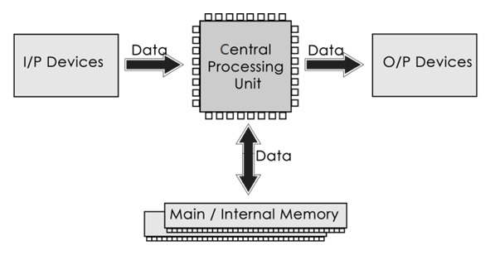

Central Processing Unit
The Central Processing Unit (CPU) is called “the brain of computer” as it controls operation of all parts of computer. It consists of two components: Arithmetic Logic Unit (ALU), and Control Unit.
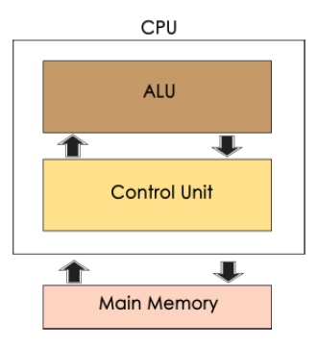

Arithmetic Logic Unit (ALU)
Data entered into computer is sent to RAM, from where it is then sent to ALU, where rest of data processing takes place. All types of processing, such as comparisons, decision-making and processing of non-numeric information takes place here and once again data is moved to RAM.

Control Unit
As name indicates, this part of CPU extracts instructions, performs execution, maintains and directs operations of entire system.

Functions of Control Unit
Control unit performs following functions −
- It controls all activities of computer
- Supervises flow of data within CPU
- Directs flow of data within CPU
- Transfers data to Arithmetic and Logic Unit
- Transfers results to memory
- Fetches results from memory to output devices

Memory Unit
This is unit in which data and instructions given to computer as well as results given by computer are stored. Unit of memory is “Byte”.
8 Bits = 1 Byte
4 Bits = 1 Nibble

